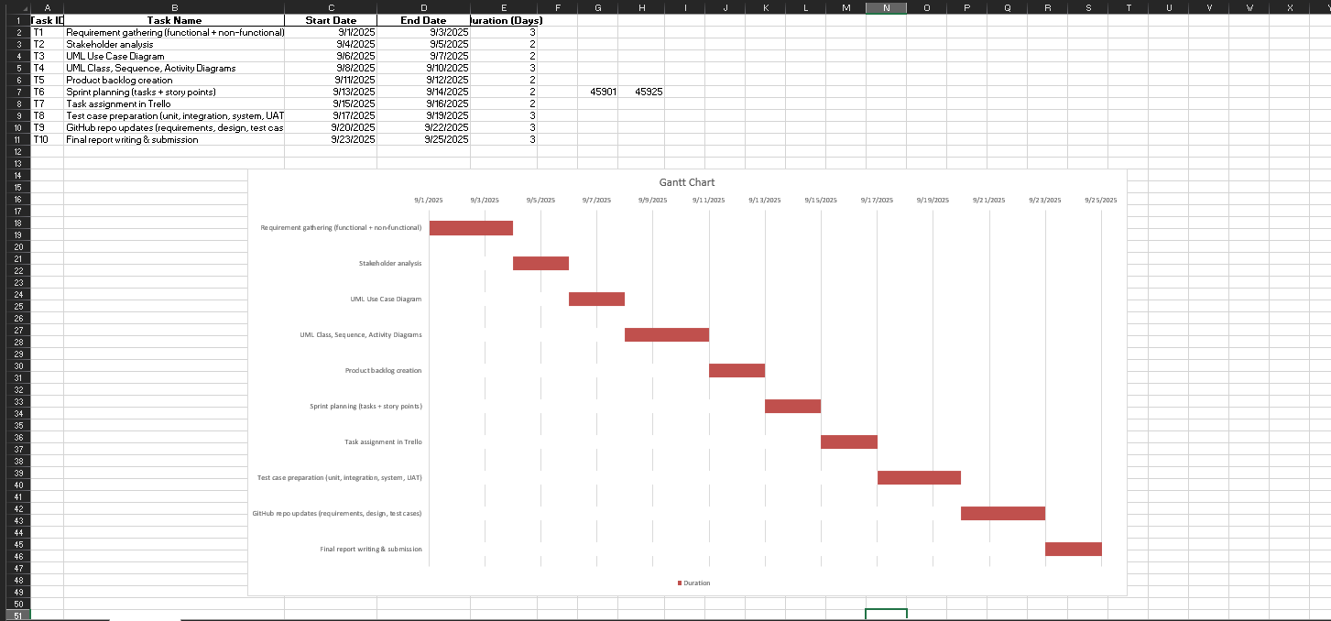

Gantt Chart

A Gantt chart is a project management tool that visually represents a project's schedule. The image you provided shows a typical Gantt chart, likely created in a spreadsheet program, which uses horizontal bars to illustrate task durations over a timeline. The chart's main purpose is to provide a clear, at-a-glance overview of a project. It has two primary sections: a vertical list of tasks on the left, detailing each activity's name, start date, end date, and duration, and a horizontal timeline on the right. On this timeline, red bars are used to represent each task. The position of a bar indicates its scheduled start and end dates, and its length reflects the task's duration. The sequential arrangement of these bars also helps to visualize task dependencies, showing which tasks must be completed before others can begin. This makes the chart an effective tool for tracking project progress and understanding the overall schedule.